1. Create project and application

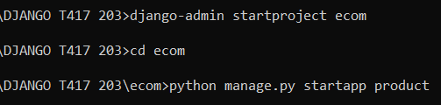

1. Open project in vs code
2. Register application in settings.py